**EX NO 3 VALIDATION OF CREDIT CARD SYSTEM USING JAVASCRIPT.**

**AIM**

To implement a java script program to validate a credit card system.

**OBJECTIVES**

To learn about the usage of validations in Java scripts . To learn the ways of designing forms in HTML using tags

**SOFTWAREREQUIRED**

Notepad, Any Browser viz., Mozilla, Chrome

**DESCRIPTION**

Java script is not specifically HTML related, but interacts with HTML and DHTML when used in a browser. It’s a more traditional programming language, in that you can write a series of instructions to compute what kinds of actions should be taken based on various conditions, repeat things a variable number of times, and just generally take more complex and sophisticated actions. The items on a webpage, the events that a web page might want to act on (like moving your mouse over text), and the resulting changes to the web page that you might want to have happen resulting from those events (like changing the color of text). Java script, however, is really web, and HTML, independent. It adds programming things like loops, and variables and functions. The point of Java script is that it is a client side technology. It allows you to do stuff on the browser instead of the server. Simple example-you want to let the user enter some numbers and then you perform some

calculation on these and display the results. With Java script, this would all happen on the browser, the server will not be involved.

**PROCEDURE:**

1.Open a notepad and create a file named job1.html

2.Now type the code with validations.

3.Open a browser and type the file name with url to display the form.

**ALGORITHM:**

**Step1:** Create a script that includes a function that validates for name, email id, do band phone no etc.,

**Step2:** If wrong or missing data is entered in the form fields an alert is displayed.

**Step4:** If all the data entered by the user are correct the form is submitted with a thank you Message as feedback.

**PROGRAM:**

**FORM.HTML**

<!DOCTYPE html>

<html lang="en">

<head>

<meta charset="UTF-8">

<meta http-equiv="X-UA-Compatible" content="IE=edge">

<meta name="viewport" content="width=device-width, initial-scale=1.0"> <title>Document</title>

<link rel="stylesheet" href="form.css">

</head>

<body>

<center><h1 style="color: white;"><b>CREDIT CARD VALIDATION</b></h1></center> <script>

function validateForm() {

var x = document.forms["myForm"]["fname"].value; if (x == "") {

alert("First Name must be filled out");

return false;

}

var y = document.forms["myForm"]["lname"].value; if (y == "") {

alert("Last Name must be filled out");

return false;

}

var b = document.forms["myForm"]["email"].value; if (b == "") {

alert("Email id must be filled out");

return false;

}

var d = document.forms["myForm"]["dob"].value; if (d == "") {

alert("DOB must be filled out");

return false;

}

var e = document.forms["myForm"]["credit"].value; if (e == "") {

alert("Credit card number must be filled out");

return false;

}

else if(e.length<16){

alert("Credit card number is less than 16");

return false;

}

var f = document.forms["myForm"]["exp"].value; if (f == "") {

alert("Expiry date must be filled out");

return false;

}

var g = document.forms["myForm"]["cvv"].value; if (g == "") {

alert("cvv must be filled out");

return false;

}

else if(g.length<3){

alert("CVV is less than 3");

return false;

}

alert("Successfully completed");

}

</script>

<div class="contaniner">

<center>

<form name="myForm" onsubmit="return validateForm()" method="post" class="container"> <b>FIRST NAME <br> </b><input type="text" placeholder="fname" name="fname"><br>

<br>

<b>LAST NAME <br> </b><input type="text" placeholder="lname" name="lname"><br> <br>

<b>EMAIL <br> </b><input type="email" placeholder="email" name="email"><br> <br>

<b>DOB <br> </b><input type="date" name="dob"><br>

<br>

<b>CREDIT CARD NUMBER<br> </b> <input type="text" placeholder="creditno" maxlength='16' name="credit"><br>

<br>

<b>EXPIRY DATE<br> </b><input type="month" id="inputExpDate" name="exp" placeholder="MM / YY" maxlength='7'><br>

<br>

<b>CVV <br></b><input type="password" class="cvv" name="cvv" placeholder="CVV" maxlength="3"><br>

<br>

<center><input type="submit" value="SUBMIT" class="btn"></center>

</form>

</center>

</div>

</body>

</html>

**FORM.CSS:**

.container{

margin: auto;

width: 50%;

color: white;

}

input[type=text],input[type=password],input[type=email],input[type=number],input[type=date],input

[type=month]{

width: 50%;

padding: 15px;

margin: 5px 0 22px 0;

border: none;

background: #f1f1f1;

}

.btn{

background-color:white;

color:black;

font-family: 'Times New Roman', Times, serif;

font-size: 20px;

padding: 16px 20px;

border: none;

cursor: pointer;

width: 100%;

opacity: 0.9;

}

body{

background-image: url(kranti\ logo.png);

}

**OUTPUT:**



Page No.:

29

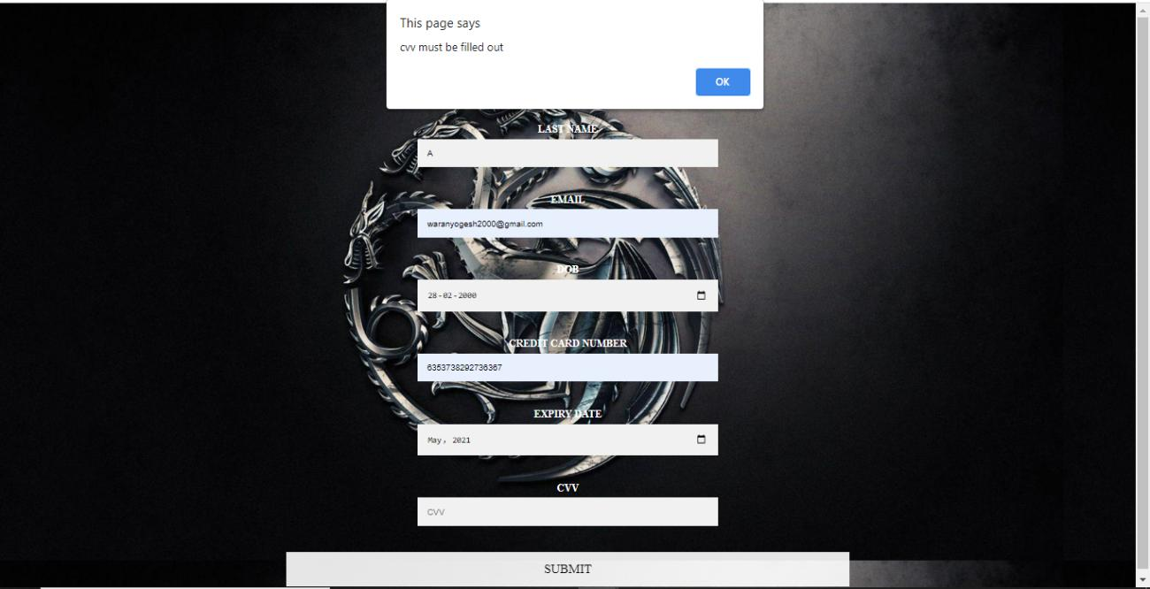

**RESULT:**

The validation of the credit card system using javascript completed.